March | Hummingbirds Pre-K Room 165  Ms. Maestas
2020 | 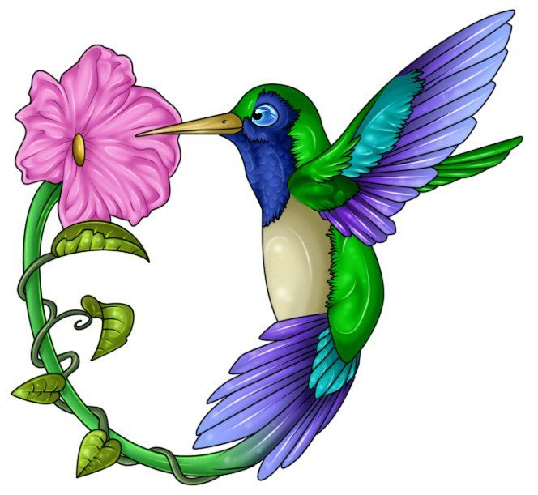
Sunday | Monday | Tuesday | Wednesday | Thursday | Friday | Saturday
1 | 2 | 3 | 4 | 5 | 6 | 7
 | Texas Independence Day  Dr. Seuss  Go Texas Week  Birthday/Read Across America Day | John Baptizes Jesus Activity | Green collage with shapes | Rodeo Program 6:45pm | Rodeo Day 9-12
8 | 9 | 10 | 11 | 12 | 13 | 14
Daylight Saving Time Begins | Spring Break. No Preschool—Full-time students only |  |  |  | National Good Samaritan Day
15 | 16 | 17 | 18 | 19 | 20 | 21
 | Trinity Shamrock | St. Patrick’s Day—wear green! | Rhythm Following | First Day of Spring  Paint Alphabet on Butcher Paper
22 | 23 | 24 | 25 | 26 | 27 | 28
 | Memory Verse Chain | Easter Cross Boxes | Parent Chapel/Lunch 11am | 7 Days of Creation Booklet | Alphabet and Number Bingo
29 | 30 | 31
Baptism Marker 11am  5th Sunday Family Fun Event 5pm | Get Well Greeting Cards | Heart Pass

Unit Topic:  Exploring God’s Living Creation  Emphasis:  Lent  Letters: Dd, Gg, Qq | Numbers: 16, 17, 18  Shape: diamond, octagon  Color: green  Sight words:  the, green | Community Worker:  Food Suppliers  Fruit of the Spirit:  Self-Control | Memory Verse:  “Come and follow me,” Jesus said. | Basic Truth:  Jesus wants to be my friend forever.  Key Question:  Who can you follow? | Bottom Line:  I can follow Jesus.  Other Bible Verse:  Do to others what you would have them do to you. Matthew 7:12

